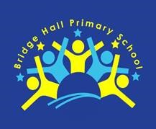

Actively Promoting British Values at
Bridge Hall Primary School

The DfE have recently reinforced the need “to create and enforce a clear and rigorous expectation on all schools to promote the fundamental British Values of democracy, the rule of law, individual liberty, mutual respect and tolerance of those with different faiths and beliefs.”

In line with the with the Department for Education’s five-part definition, we promote the following British values at Bridge Hall Primary School;
• Democracy
• The rule of law
• individual liberty
• mutual respect
• tolerance of those of different faiths and beliefs

At Bridge Hall Primary School students will encounter these principles throughout everyday school life. In particular, our promotion of spiritual, moral, social and cultural understanding is where these value are explicitly taught in a range of ways including through circle times and focused events such as ‘British Values Day’ and ‘Equality and Diversity week’. Additionally, the values are taught in R.E and interwoven within our skills based curriculum which gives children real and meaningful opportunities to explore these values. At Bridge Hall Primary School, we are certain that the active promotion of British Values means that children are enabled to develop a sense of community and begin to develop their understanding of their role and responsibilities within it.

Bridge Hall Primary School takes the opportunity to actively promote British Values through daily whole school assemblies where a range of British Values are explored. Our whole school systems and structures lend themselves to the active promotion of British Values,. Bridge Hall Primary School, also actively promotes British Values by challenging pupils, staff or parents who express opinions contrary to fundamental British values, including ‘Extremist Beliefs’, in appropriate ways.

Our British values and SMSC displays throughout the school

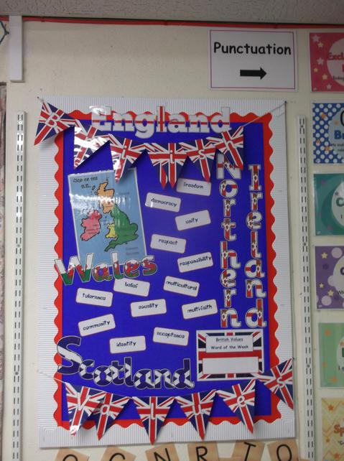

3 / 4
Pupil voice is significant at Bridge Hall Primary School. Our Pupil Voice champions play a strong role in our school. They are elected by their class peers and are involved in making the school a better place to learn. Pupils have a great amount of input in regards to what and how they learn as they decide upon the topic they would like to learn about each half term and the teachers use this to inform planning. The pupil’s voice is also heard through pupil conferencing and through pupil questionnaires. We know that the formation of the school champions and the active participation of our pupils will sow the seeds for a more sophisticated understanding of democracy in the future.
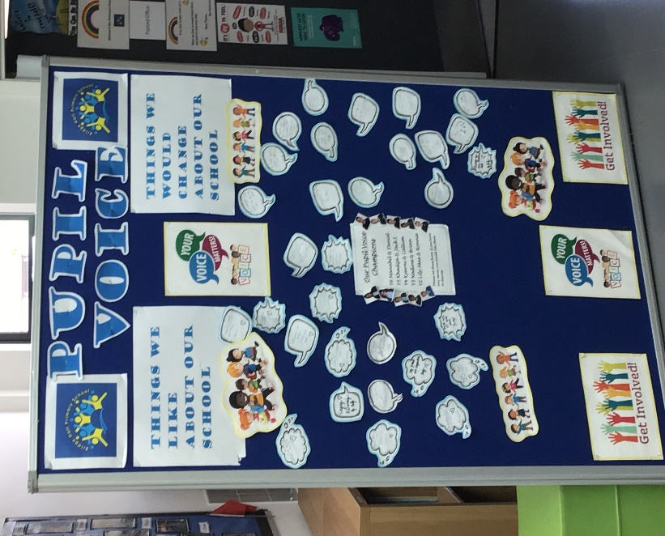

The Rule of Law
Our pupils will encounter rules and laws throughout their entire lives. We want our pupils to understand that whether these laws govern the class, the school, the neighbourhood or the country, they are set for good reasons and must be adhered to.
This understanding of the importance of rules will be consistently reinforced through assemblies, in classes, around the school and through our curriculum. The involvement of our pupils in the creation of the school rules helps them to understand the reasons behind the rules and the consequences if they are broken. Through SMSC questions and circle times, we allow opportunity to debate and discuss the reasons for laws so that children can recognise the importance of these for their own protection. Throughout the year we welcome visits from members of the wider community including the police, the fire brigade and many more. We believe that clear explanations and real life stories emphasise the importance of the rule of law for our pupils. Opportunities for children to take more responsibility around the school are encouraged and such roles as RA champions who do break and lunch time monitoring duty.
Individual Liberty
We invest a great deal of time in creating a positive culture in our school, so that children are in a safe environment where choices and freedoms are encouraged and valued. Pupils are given the freedom to make a variety of meaningful choices such as choosing the level of challenge they want to progress to in a lesson and taking ownership of their child- led learning through their Restorative approaches training.
We offer a range of clubs which pupils have the freedom to choose from, based on their interests and skills. Through our E-Safety days, we educate children on their rights and personal freedoms as well as supporting them in recognising how to exercise these freedoms safely. In weekly circle times, all children are encouraged to share their feelings in a safe way. Children take responsibility as RA champions to help resolve conflicts and repair relationships. They are available every lunch time for children and offer a safe place for discussions about any play time issues that may have arisen; it is at these meetings that the children’s voices can be heard and an appropriate resolution will be decided on by the children themselves. At Bridge Hall Primary School, we believe that valuing choice and freedom in daily school life will foster a value for individual liberty as the children embark upon their adult lives.
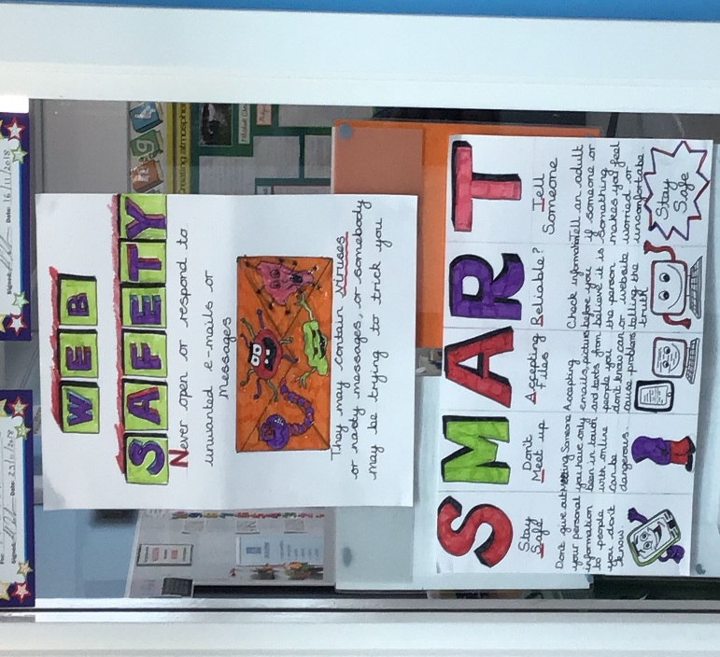

Mutual respect
Mutual respect is at the core of our school life. The children learn to treat each other and staff with great respect. This is evident when walking around the School and in the classrooms. Children are encouraged to showcase their work on their class scrapbook and regularly contribute respectful comments about the work of others. Each class draws up a set of class rules or a class agreement each year and use this to set the tone for the level of respect that is expected throughout the year. Through Equality and Diversity week, E-Safety Days and Anti- Bullying week, the children are taught to value differences in themselves and others and most importantly to show respect to all. As mentioned previously, Restorative meetings facilitate opportunities for children to show respect to each other’s beliefs, feelings and opinions by given each child a forum to share these on and an expectation that these must be listened to.

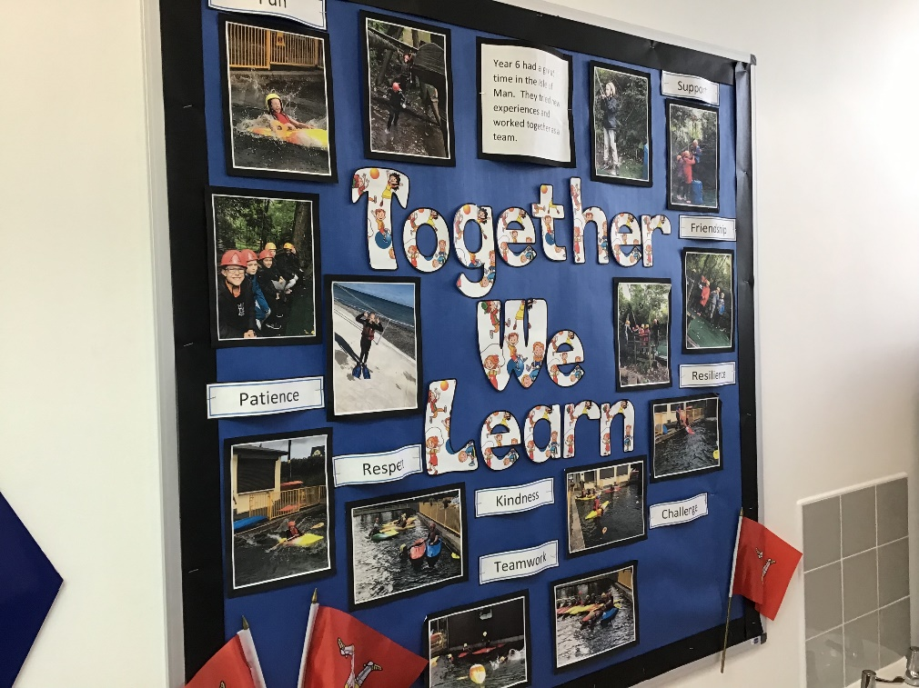

Tolerance of those of different faiths and beliefs
Bridge Hall Primary School follows the Stockport RE agreed syllabus which ensures that all children learn about the main religions and teaches respect and understanding for the cultures, beliefs, opinions and traditions or others. Class assemblies also help to contribute to the knowledge of special occasions, beliefs and customs. Additionally, Equality and Diversity weeks give children the opportunity to enhance their understanding of their place in a culturally diverse society. Through our curriculum and the routines of our daily school life, we strive to demonstrate tolerance and help children to become knowledgeable and understanding citizens who can build a better Britain for the future. We use opportunities such as the Olympics and current news and events from around the world to help the children study and learn about life and cultures in different countries.

