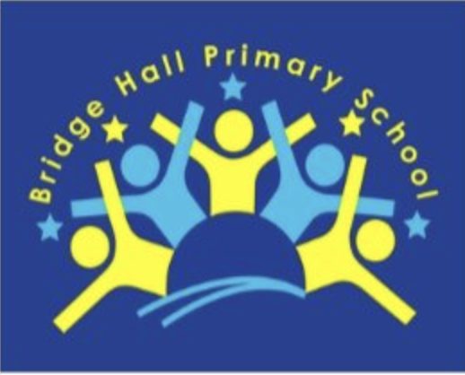

Bridge Hall Primary School Governing Board

Impact Statement 2023 - 2024

At Bridge Hall Primary School, the governing board collaborates closely, fulfilling our three essential responsibilities:
- Establishing a clear vision, ethos, and strategic direction.
- Holding executive leaders accountable for both the educational outcomes of the school and its students, and for staff performance management.
- Monitoring the school's financial health to ensure funds are used effectively.

We acknowledge the significance of both identifying and showcasing the results of our governance. This impact statement highlights the strategic efforts of the governing board and its significant role in enhancing and contributing to the school's progress and development.

Terms of Office, Attendance, and Structure

Information regarding the terms of office for our governors, attendance records, and the structure of governance can be found on our school's website: https://www.bridgehall.stockport.sch.uk/.
The governing board plays a crucial role in shaping the strategic direction of Bridge Hall Primary School, always operating within the bounds of national laws and mindful of governance principles as well as the policies set by Stockport Local Authority.
The full governing board convenes once each term, and there are also committee meetings that are held at least once per term to ensure thorough oversight and strategic planning.

The School Improvement Plan (SIP)

In collaboration with the Headteacher and the Senior Leadership Team (SLT), the
governing board plays a pivotal role in determining the annual development priorities for the school. It is within the governing board's remit to ensure the school's leadership is
effectively guided towards fulfilling the goals and objectives outlined in the SIP. This
oversight is executed through various strategies and approaches.

Governing Board's Role in Shaping the SIP
Contribution to the SIP
The governing board members, in partnership with the Headteacher and the Senior Leadership Team (SLT), dedicate time to evaluating the current SIP, setting the priorities for the upcoming academic year. This collaborative effort underscores our commitment to continual improvement.
The governing board has taken an active role in overseeing the advancement of the SIP, with governors undertaking specific tasks to monitor its progression. These efforts are a testament to our dedication to achieving the SIP's aims and objectives.
Our committee and Full Governing Board (FGB) meetings consistently prioritise the SIP, ensuring that governors report back on their observations following each monitoring endeavour. A significant part of our governor discussions revolved around optimising the methods by which governors can effectively track SIP progress. The insights gained from these discussions have been instrumental in refining our monitoring approach for the year ahead.
Monitoring progress of the SIP
In-depth analysis of both internal and external data for the 2022/23 academic year has been conducted, with plans to extend this analysis into the Autumn term 2023 meetings. Subject Leaders are given the opportunity to present to the governors about specific SIP areas, showcasing evidence gathered from staff and pupil feedback activities as well as examples of student work. This process enables governors to have a thorough understanding of the impact of our strategies and the progress being made towards our goals.
Committees
To ensure that our governing board operates both strategically and efficiently, we delegate specific governance responsibilities to committees. This approach allows us to concentrate on the key areas of school improvement that have been collectively agreed upon. The assignment of governors to these committees is a thoughtful process. We conduct a skills audit to understand each governor's strengths and experiences, which informs our encouragement for their participation in particular committees. However, it's important to note that governors have the autonomy to choose their committee memberships. At the start of each academic year, we review the committee structure to ensure it aligns with our strategic goals and the evolving needs of our school. For an up-to-date overview of our committee structure please visit our website.

Finance (Resources, Premises, Staffing, Health & Safety)
School Improvement Committee
Pay Panel
Pay Appeals Panel
Performance Management (Headteacher)
Committee | Overview of work | Impact
School Improvement | The committee has a very good understanding of our curriculum's intent, how this is implemented and the impact it has. Committee members have regularly visited school to see aspects of the curriculum in action and speak to pupils and staff.  In committee meetings, members have reviewed the information provided on published school performance data. In addition, they have analysed internal anonymised pupil progress data. Governors also take external validation reports into account when assessing progress and attainment.  Policies and procedures have been reviewed to ensure that these are fit for purpose and meet not only our legal responsibilities, but also our vision for the school and our pupils. | Governors have been able to monitor in-year progress and attainment and triangulate this with learning walks on curriculum developments, book looks and pupil voice monitoring. This has given governors a clear picture of the progress of specific groups of pupils with reference to the SIP priority areas. From this, the governors have been able to focus on additional areas for development.
Finance | This committee monitors the school budget and finances and also oversees premises and health & safety. The committee has undertaken setting and monitoring of the budget, completion of School Financial Value Standard (SFVS) and Benchmarking exercise, overseen teachers’ and Headteacher pay progression and discussed and monitored expenditure on strategic projects. | We continue to closely monitor the school budget to ensure the school can cope with reduced funding and rising costs. This is a constant challenge and the pandemic and global financial situation are still giving more challenges in relation to managing the budget.  Benchmarking and SFVS show that the school makes very good use of resources and meets all the requirements for good financial management.

Monitoring activity

One of the key functions of a governing board is to undertake strategic monitoring activity, the purpose of which is to triangulate information shared with governors by the Senior Leadership Team (SLT). The governing board undertakes a wide range of monitoring activities, including:

- Monitoring visits to the school to meet with subject leader/s in specific subject areas to discuss aspects of the curriculum, undertake learning walks and lesson drop-ins.
- Monitoring visits by the Health & Safety link governor to meet with the Headteacher, School Business Manager and caretaker.
- Monitoring visits by the Safeguarding Governor to meet with Designated Safeguarding Lead (Headteacher) and School Business Manager regarding Single Central Record.
- Monitor visits by the SEND link governor to meet with SEND Lead.
- Meet with School Improvement Committee to discuss reports following Quality Assurance visits.
- Informal visits to school - performances, sporting events, Christmas Fair.
- Pupil Voice via the School Committee.
- Inviting staff members to governing board meeting to report on key areas.
- Listening to presentations from staff members on aspects of the curriculum from the SIP.

Governor Training

During the academic year governors have attended training sessions run by the LA, NGA and training sessions held on-line and e-learning modules. This training has included:-

- New Governor Training
- Governor Refresher
- EYFS Statutory Framework
- Safer Recruitment Workshop
- Strategic Focus for Governors
- Ofsted for Governors
- Budget Monitoring
- Health & Safety for Governors
- Effective PSHE/e-Safety

