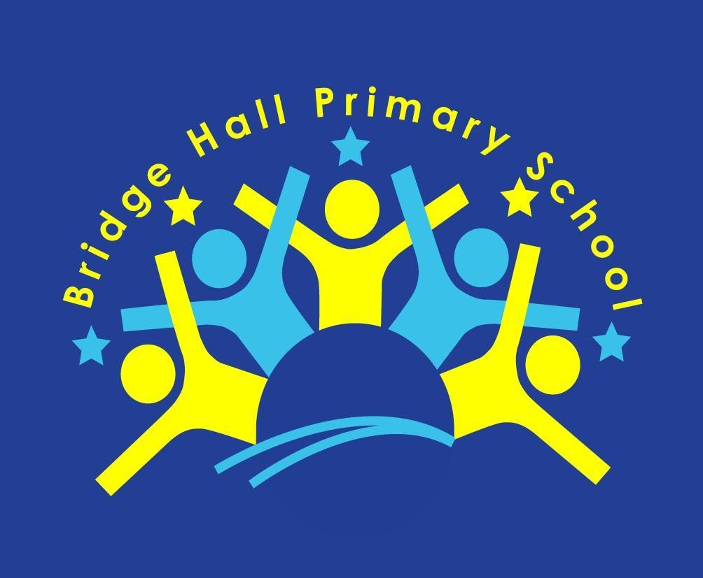
Bridge Hall Primary School

Relationships and
Sex Education Policy (RSE)

Date: 15th November 2023
Today’s children and young people are growing up in an increasingly complex world, living their lives both on, and offline. This presents many positive and exciting opportunities, but also challenges and risks.
Introduction

Bridge Hall Primary School considers that Relationships & Sex Education (RSE) is an integral part of the Personal, Social and Health Education (PSHE) curriculum.
- PSHE makes a significant contribution to the promotion of young people’s personal and social development.
- Through the promotion of PSHE, skills are developed that our pupils need for them to grow and flourish as individuals and members of society.
- PSHE contributes to helping children and young people to build their personal identities, confidence, and self-esteem.
- PSHE enables them to recognise and manage their emotions and to communicate positively in a range of different scenarios.
We believe that Relationships and Sex Education includes supporting young people in developing self-confidence in preparing them for the physical and emotional changes into adulthood.
It promotes an understanding of the range of family types and other people who contribute to providing children with the care, love and support they need to grow and develop.
We passionately believe this is paramount for teaching pupils the skills and knowledge to safeguard themselves, and prepare children and young people for the challenges, opportunities, and responsibilities of adult life, building healthy relationships and staying safe.
We aim to achieve this by
• Providing PSHE Education that is dynamic, relevant, and appropriate for the challenges and contexts of 21st century life as part of our commitment to broad outcomes for children.
• Teaching children about equality and diversity as is our duty under the Equalities Act (2010).
• Teaching about different family structures including single parent families, LGBT+ parents, adoptive parents, foster parents/carers amongst other structures.
•Providing our pupils with Relationships and Sex Education that is age appropriate and contributes to lifelong learning and pupil well-being.
•Having a strong commitment to confidentiality and to providing a safe learning environment where all feel respected whilst safeguarding vulnerable pupils.
•Informing and working with parents and families to support and promote our work in school by making policies and schemes of work available in school, and on our website and supporting them should they have questions or concerns about RSE.
•Using a wide range of age appropriate examples, role models, texts, images and resources across the wider school curriculum which meet our duty under the Equalities Act (2010) and the schools’ wider commitment to the British values of democracy, rule of law, individual liberty and mutual respect and tolerance of those with different faiths and beliefs e.g. English texts which include different family structures or display images of famous people of different faiths and beliefs.

•Working collaboratively with partners and agencies such as healthcare professionals to enrich and support pupil’s learning in Relationships and Sex education where appropriate or necessary.

Legal Framework
This policy has due regard to all relevant legislation and statutory guidance including, but not limited to, the following:
- Equality Act 2010
- Children and Social Work Act 2017
- DfE Relationships Education, Relationships and Sex Education (RSE) and Health Education (statutory guidance) 2019
- DfE ‘Keeping Children Safe in Education’
- DfE ‘National curriculum in England: science programmes of study’
This policy operates in conjunction with the following school policies:

• Safeguarding Policy Anti-Bullying Policy
• Relationships and Behaviour Policy E-safety Policy
• SEND Policy Wellbeing Policy
• Equality and Diversity Policy Teaching & learning policy
• RE Policy
Definition of Relationships Education
The focus in our primary school is on teaching the fundamental building blocks and characteristics of positive relationships, with reference to friendships, family relationships, and relationships with other children and with adults.
Teaching about families requires sensitive and well-judged teaching based on knowledge of pupils and
their circumstances. Families of many forms provide a nurturing environment for children. (Families can include for example, single parent families, LGBT+ parents, families headed by grandparents, adoptive parents, foster parents/carers amongst other structures.) We take great care to ensure that there is no stigmatisation of children based on their home circumstances and needs, to reflect sensitively that some children may have a different structure of support around them e.g. looked after children or young carers.
Definition of Sex Education

The DfE continues to recommend that all primary schools should have a sex education programme tailored to the age and the physical and emotional maturity of the pupils.
As a maintained primary school, we have chosen to teach aspects of sex education (which go beyond the national curriculum for science in Year 5), these are set this out in this policy following consultation with with a parent group.
Although it is not statutory to deliver sex education outside of the science curriculum (which is statutory) at primary level, the DfE recommends that all primary schools should have a sex education programme in place. At Bridge Hall Primary School we do teach pupils sex education beyond what is required of the science curriculum – the content is tailored to the age, and physical and emotional maturity of pupils, and ensures that boys and girls are prepared for the changes that adolescence brings, drawing on knowledge of the human life cycle.
Aims of Relationship and Sex Education
Taking account of the age, maturity and needs of the pupils, Relationships and Sex Education aims to:
- To give children the confidence and self-esteem to value themselves and others
- To understand about the range of relationships, including the importance of family for the care and support of children
- To develop confidence in talking, listening, and thinking about feelings and relationships
- To be able to name parts of the body and describe how their bodies work
- To be prepared for puberty
- To understand the consequences of their actions and behave responsibly within relationships
- To be able to recognise unsafe situations and be able to protect themselves and ask for help and support
- To understand the role the media plays in forming attitudes
- To understand what a healthy relationship is both on and offline
- Ensure children know how and where to access appropriate support
Everyone involved in the teaching RSE will be clear about the boundaries of their legal and professional roles and responsibilities. Teachers will be aware that effective RSE, which brings an understanding of what is and is not acceptable, may lead to disclosure of a child protection issue.
Safeguarding & Confidentiality
If a staff member has any concerns or a child discloses information giving cause for concern, this must be report to the DSL and the schools safeguarding policy must be followed.
Equality and Diversity
The school understands its responsibilities in relation to the Equality Act 2010, meaning that school cannot unlawfully discriminate against any pupil because of their sex, race, disability, religion or belief or sexual orientation. RSE will be taught to ensure quality of access for all pupils and avoiding discrimination.
We ensure our Relationships and Sex education programme is sensitive to the needs of all our pupils and their families by:
- Being aware of pupils’ individual characteristics, backgrounds, attitudes, and feelings.
- Differentiating teaching and learning from our planned scheme of work to allow access to Relationships and Sex education for all our pupils including those with SEND or EAL.
- The school understands that pupils with SEND or other needs (such as those with social, emotional or mental health needs) are entitled to learn about relationships, sex and health education, and the programme will be designed to be inclusive of all pupils.
- Ensuring freedom from all forms of bullying including homophobic, biphobia and transphobic (LGBT+phobia) bullying as is our duty within the Equalities Act (2010) through a zero-tolerance approach within all our policies and practice
Role of the Headteacher
It is the responsibility of the Headteacher to:
•Ensure that parents and staff are informed about our RSE policy
•The policy is implemented effectively.
•Ensure that members of staff are given sufficient training, so that they can teach effectively and handle any difficult issues with sensitivity.
•Monitor this policy on a regular basis and report to governors on the effectiveness of the policy.
Role of Subject Lead/Team
•Overseeing the delivery of the science and / or PSHE.
•Ensuring the subject content is age-appropriate and high-quality.
•Ensuring teachers are provided with adequate resources to support teaching of the subjects.
•Ensuring the school meets its statutory requirements in relation to the relationships, sex and health curriculum.
•Ensuring the relationships, sex and health curriculum is inclusive and accessible for all pupils.
•Working with other subject leaders to ensure the relationships, sex and health curriculum complements, but does not duplicate, the content covered in the national curriculum.
•Monitoring and evaluating the effectiveness of the subjects and providing reports to the headteacher.
The Governing Board should make sure that: -
•Ensuring all pupils make progress in achieving the expected educational outcomes.
•Ensuring the curriculum is well led, effectively managed and well planned.
•Evaluating the quality of provision through regular and effective self-evaluation.
•Ensuring teaching is delivered in ways that are accessible to all pupils with SEND.
•Providing clear information for parents on subject content and their rights to request that their children are withdrawn from non-statutory elements of the curriculum.
• The subjects are resourced, staffed, and timetabled in a way that ensures that the school can fulfil its legal obligations.

RSE will be delivered as part of the school’s PSHE curriculum which has been organised in line with the statutory requirements outlined in the ‘Relationships, Education, Relationships and Sex Education (RSE) and Health Education’ guidance.https://www.gov.uk/government/publications/relationships-education-relationships-and-sex-education-rse-and-health-education
Organisation of the Curriculum

school setting)
At Bridge Hall Primary School, we have the flexibility to deliver the content in a way that is age and developmentally appropriate and sensitive to the needs and religious background of all our pupils.
At the points we consider it appropriate to teach pupils about more sensitive topics we will ensure that this content is fully integrated into the relationships, sex and health curriculum, rather than delivered as a standalone unit or lesson.
- All teachers will have responsibility for planning and delivering RSE.
- Everyone involved in the teaching of RSE will follow the school policy.
- A balanced and non-judgmental approach will be taken, and the personal beliefs and attitudes of teachers will not influence the teaching of RSE. .
At Bridge Hall Primary School, a number of teaching strategies will be used, to deliver an inclusive RSE curriculum, including:
- Establishing ground rules with pupils.
- Using ‘distancing’ techniques (e.g. case studies)
- The provision of a ‘question box’ during each planned session
- Dealing with children’s questions in an appropriate manner
- Using discussion and age appropriate materials.
- Encourage reflection
At Bridge Hall Primary School we follow the Kapow Primary scheme of work, which is split into 5 core themes. Please see the whole school curriculum overview for a full breakdown.
The scheme of work maps out the lessons/units for each year group, which progresses and returns to themes as children move through the school
Core Theme 1: Family and relationships
Core Theme 2: Safety and the changing body
Core Theme 3: Health and wellbeing
Core Theme 4: Citizenship
Core Theme 5: Economical wellbeing
By the end of primary school, pupils will have been taught content on:
- Families and people who care for me
- Caring friendships
- Respectful relationships
- Online relationships
- Being safe
The school seeks opportunities to draw links between relationships, sex and health education and other curriculum subjects wherever possible to enhance pupils’ learning. Relationships, sex and health education will be linked to the following subjects in particular:
Curriculum Links

• Science – pupils learn about the main external parts of the body and changes to the body as it grows from birth to old age, including puberty.
• Computing and ICT – pupils learn about e-safety, including how to use technology safely, responsibly, respectfully and securely, how to keep personal information private and how to access help and support.
• Circle time - Gives pupils the opportunity for discussion and listening to other people views and opinions
• PSHE – pupils learn about respect and difference, values and characteristics of individuals.
Assessment
As with any learning, the assessment of pupils’ PSHE and RSE is important as it enables the teacher to gauge individuals’ progress. Pupils have the opportunity to reflect upon their personal learning experience, set goals, and record their understanding in a range of ways, including: - reflective diaries, class discussions, group work, questionnaires / surveys, and peer assessment.
Pupil voice will also be used to inform future planning for PSHE and RSE, to ensure it is both relevant and effective.
Monitoring and Evaluation
The PSHE subject leader will monitor delivery of PSHE with teaching staff to ensure consistent and coherent curriculum provision including:
• Self-evaluations
• Lesson observations
• Topic feedback forms
• Learning walks
• Lesson planning scrutiny
Consultation & the Role of Parents & Carers
The school is aware that the primary role in children’s Relationships and Sex Education lies with parents and carers. We wish to build a positive and supporting relationship with the parents of children at our school through mutual understanding, trust and co-operation. Similarly, we also understand how important parents/ carers’ views are in shaping the curriculum. In promoting this we:
- Will consult and inform parents/carers about RSE through the school prospectus, letters, school website and information sessions.
- Inform parents about our school’s Relationships and Sex Education policy and practice.
- Answer any questions that parents may have about the Relationships and Sex Education of their child.
- Take seriously any issue that parents raise with teachers or governors about this policy or the arrangements for Relationships and Sex Education in our school.
Answering Difficult Questions
If a child asks an explicit or difficult question, the staff will use their professional judgement in deciding the best way to answer it. This may be through individual work or discussion with the child / parent. If the staff member is concerned, they must discuss the matter with Designated Safeguarding Lead, Parent/Carer if appropriate and always follow the schools safeguarding policy.
All questions will be handled sensitively, and consideration will be given to religious or cultural factors, and to parents’ wishes before questions are answered.
Language
At Bridge Hall Primary School we believe it is important that acceptable and unacceptable terminology is clarified and after initial discussion, correct biological terms will always be used for teaching.
Teaching children common terminology to describe genitals is important in relation to safeguarding. This aspect of teaching may link with elements of the Science curriculum around naming body parts. It also links to the following Relationships Education outcome: ‘how to report concerns or abuse, and the vocabulary and confidence needed to do so’.
Right of Withdrawal
Relationships and Health Education are statutory at primary school and there is no right to withdraw from these subjects. It is important for all children to be taught the content on such essential matters like friendships and keeping safe both on and offline.
As sex education is not statutory at primary level (other than what is taught as part of the science curriculum), parents / carers have the right to request to withdraw their child from all or part of the sex education curriculum.
Before considering this option, we would always encourage parents to come and talk to us.
(For more information, please go to https://www.gov.uk/government/publications/relationships-sex-and-health-education-guides-for-schools)
The Role of External Agencies
The school may liaise with external agencies to support and compliment the schools PSHE/RSE programme of study. All agencies will be aware of the schools policies and procedures and their role within them.
Any matters reported by visitors will be dealt with in line with the our Safeguarding Policy.

We ensure that the teaching delivered by visitors fits with the planned programme of study. The
content of lessons provided by external agencies is age appropriate and accessible for all pupils and
is approved by the school in advance of delivery.
Review
• The policy will be reviewed annually.
• The policy will be reviewed in light of any changes to statutory guidance, feedback from parents, staff or pupils, and issues in the school or local area that may need addressing.
• The governing board is responsible for approving this policy.
• Any changes made to this policy will be communicated to all staff, parents and, where necessary, pupils.
Headteacher: Alexandra Jamieson
Chair of Governors: David Trafford
Policy Review Date: November 2024

Appendix 1: By the end of primary school children should know
Relationships Education
Families and  people who  care for me | Pupils should know  • that families are important for children growing up because they can give love, security, and stability.  • the characteristics of healthy family life, commitment to each other, including in times of difficulty, protection and care for children and other family members, the importance of spending  time together and sharing each other’s lives.  • that others’ families, either in school or in the wider world, sometimes look different from their family, but that they should respect those differences and know that other children’s families  are also characterised by love and care.  • that stable, caring relationships, which may be of different types, are at the heart of happy families, and are important for children’s security as they grow up.  • that marriage represents a formal and legally recognised commitment of two people to each other which is intended to be lifelong.  • how to recognise if family relationships are making them feel unhappy
Caring  friendships | Pupils should know  • how important friendships are in making us feel happy and secure, and how people choose and make friends.  • the characteristics of friendships, including mutual respect, truthfulness, trustworthiness, loyalty, kindness, generosity, trust, sharing interests and experiences and support with problems and difficulties.  • that healthy friendships are positive and welcoming towards others, and do not make others feel lonely or excluded.  • that most friendships have ups and downs, and that these can often be worked through so that the friendship is repaired or even strengthened, and that resorting to violence is never right.  • how to recognise who to trust and who not to trust, how to judge when a friendship is making them feel unhappy or uncomfortable,  managing conflict, how to manage these situations and how to seek help or advice from others, if needed.
Respectful  relationships | Pupils should know  • the importance of respecting others, even when they are very  different from them (for example, physically, in character, personality or backgrounds), or make different choices or have different preferences or beliefs.  • practical steps they can take in a range of different contexts to improve or support respectful relationships.  • the conventions of courtesy and manners.  • the importance of self-respect and how this links to their own happiness.  • that in school and in wider society they can expect to be treated with respect by others, and that in turn they should show due respect to others, including those in positions of authority.  • about different types of bullying (including cyberbullying), the impact of bullying, responsibilities of bystanders (primarily  reporting bullying to an adult) and how to get help.  • what a stereotype is, and how stereotypes can be unfair, negative, or destructive.  • the importance of permission-seeking and giving in relationships with friends, peers and adults
Online  relationships | Pupils should know  • that people sometimes behave differently online, including by pretending to be someone they are not.  • that the same principles apply to online relationships as to face-toface relationships, including the importance of respect for others  online including when we are anonymous.  • the rules and principles for keeping safe online, how to recognise risks, harmful content and contact, and how to report them.  • how to critically consider their online friendships and sources of information including awareness of the risks associated with people they have never met.  • how information and data is shared and used online
Being safe | Pupils should know  • what sorts of boundaries are appropriate in friendships with peers and others (including in a digital context).  • about the concept of privacy and the implications of it for both children and adults; including that it is not always right to keep secrets if they relate to being safe.  • that each person’s body belongs to them, and the differences between appropriate and inappropriate or unsafe physical, and  other, contact.  • how to respond safely and appropriately to adults they may encounter (in all contexts, including online) whom they do not  know.  • how to recognise and report feelings of being unsafe or feeling bad about any adult.  • how to ask for advice or help for themselves or others, and to keep trying until they are heard.  • how to report concerns or abuse, and the vocabulary and confidence needed to do so.  • where to get advice e.g. family, school and/or other sources.

